*Software Requirements Specification*

Table of Contents

Abstract 2

Objective and Scope 2

Requirements 4

Functional Requirements 4

Non-Functional Requirements 6

Design 7

High Level Design 7

Low Level Design 8

Implementation 10

Flow Chart 10

Use Case Diagram 11

Sequence Diagram 12

Class Diagram 13

Test Cases 13

# Abstract

The Online Shopping System Project Report encapsulates the development and implementation of an advanced e-commerce platform tailored to meet modern shopping needs. This project aims to create a user-friendly, secure, and feature-rich online shopping experience for customers.

Key components of the Online Shopping System include user registration and authentication, a comprehensive product catalog with search and filtering capabilities, a shopping cart for easy purchase management, a streamlined checkout process with multiple payment options, order management functionalities, and robust customer support features.

# Objective and Scope

The objective of the Online Shopping System is to provide a convenient and efficient platform for users to browse, select, and purchase products/services online. The system aims to streamline the shopping experience by offering a user-friendly interface, secure payment options, and timely delivery of orders. Additionally, the system will facilitate inventory management, order tracking, and customer support to ensure a seamless shopping process for both buyers and sellers.

The scope of the product includes the following basic features:

* The User Management functionalities related to user registration, authentication, and profile management. It includes features such as user registration forms, email verification, password management, account recovery options, user roles, and permissions. The system ensures a seamless user experience by providing a secure and user-friendly interface for managing user accounts and personal information.
* The Product Management module focuses on maintaining a comprehensive catalog of products within the online shopping platform. It includes features such as product categorization, product details management (e.g., name, description, price, images), inventory management, product variations (e.g., size, color), product recommendations, and product reviews/ratings. The system allows administrators to add, edit, and remove products efficiently while ensuring accurate and up-to-date product information for users.
* The Shopping Cart and Checkout module facilitate the process of adding items to the cart, reviewing cart contents, and completing the purchase transaction. It includes features such as adding/removing items from the cart, updating quantities, applying discounts/coupons, viewing order summaries, selecting shipping options, and providing payment details. The system ensures a smooth checkout experience with secure payment processing and order confirmation messages.
* The Order Management module deals with managing orders from placement to delivery and beyond. It includes features such as order tracking, order history, order status updates, order fulfillment (e.g., packaging, shipping), order cancellations, returns, and refunds. The system provides users with real-time visibility into their orders and allows administrators to efficiently handle order processing and logistics.
* The Payment Integration module integrates secure payment gateways into the online shopping platform to facilitate seamless and secure online transactions. It includes features such as multiple payment methods (credit/debit cards, digital wallets, etc.), payment gateway APIs, payment processing, payment confirmation, and handling payment failures/errors. The system ensures compliance with payment industry standards and provides a smooth payment experience for users.
* The Shipping and Delivery module manages shipping options, delivery tracking, and order fulfillment processes within the online shopping system. It includes features such as shipping method selection (e.g., standard shipping, express shipping), shipping cost calculation, shipment tracking codes, delivery notifications, and order delivery status updates. The system ensures timely and accurate delivery of orders while providing users with visibility into their shipment status.
* The Customer Support module focuses on providing assistance and support to users throughout their shopping journey. It includes features such as a helpdesk system with FAQs, knowledge base articles, contact forms, live chat support, and ticketing systems for handling customer inquiries, complaints, and feedback. The system aims to enhance customer satisfaction by offering timely and effective support services across multiple communication channels.

# Requirements

Functional and Non-functional requirements are listed below.

# Functional Requirements

**User Management:**

Users should be able to create accounts with unique usernames and passwords. The system should support user authentication through email verification or SMS OTP for security. Users should have profile management capabilities, including updating personal information, addresses, and payment methods. Admins should have tools to manage user accounts, handle account-related requests, and enforce security measures like password resets and account locking.

**Product Management**:

Admins should be able to add, edit, and delete products with details such as name, description, price, images, and categories. Products should be searchable and filterable by categories, price range, brand, ratings, and other user preferences. The system should display comprehensive product details including specifications, availability, reviews, and ratings.

**Searching Items and Filters**:

Users should have a search functionality to quickly find products based on keywords, categories, or specific attributes. Filters should allow users to refine search results according to their preferences, such as price range, brand, size, color, etc. The search and filtering mechanisms should be intuitive and responsive to user inputs.

**Add to Cart and Checkout**:

Users should be able to add items to their shopping cart with quantity selection. The cart should display a summary of selected items, total price, and options to edit or remove items. The checkout process should be secure, with options for guest checkout or user login, collection of shipping information, and integration with payment gateways for order completion.

**Wishlist**:

Users should have the ability to add products to a wishlist for future reference or purchase. Wishlist items should be easily accessible and manageable, with options to move items to the cart or remove them from the wishlist.

**Order Management:**

Admins should have a dashboard to manage orders, view order details, update order status (e.g., processing, shipped, delivered), and generate invoices. Users should be able to track the status of their orders, receive order confirmation emails, and view order history for reference.

**Payment Management**:

The system should integrate with secure payment gateways to support various payment methods such as credit/debit cards, digital wallets, and online banking. Payment processing should be real-time, with confirmation notifications for successful transactions and handling of failed payments.

**Shipping and Delivery**: Users should have options to choose shipping methods (e.g., standard, express) and provide shipping addresses during checkout. The system should provide shipping cost calculations, tracking information, and delivery updates to users. Admins should manage shipping logistics, generate shipping labels, and coordinate with shipping carriers for timely deliveries.

**Customer Support**:

The system should provide channels for customer support such as FAQs, helpdesk ticketing system, live chat, or contact forms. Customer support should be responsive, providing timely assistance for inquiries, complaints, and feedback. Admins should have tools to manage customer inquiries, track support tickets, and analyze customer feedback for continuous improvement.

## Non-Functional Requirements

**Peformance:**

Performance, which includes factors like response time, throughput, and scalability. The system should be capable of handling a large number of concurrent users without significant degradation in performance, ensuring smooth browsing, quick search results, and fast checkout processes. Additionally, performance testing should be conducted to identify and address any bottlenecks or performance issues.

**Usability:**

It focusing on the system's ease of use, navigation, and user interface design. The online shopping platform should be intuitive and user-friendly, with clear labeling, organized layout, and straightforward workflows. Accessibility considerations should also be taken into account to ensure the system is usable by people with disabilities.

**Security:**

It include data encryption for sensitive information such as user credentials, payment details, and personal data. The system should also implement measures like secure authentication, session management, and protection against common security threats such as SQL injection, cross-site scripting (XSS), and cross-site request forgery (CSRF).

**Reliability:**

It emphasizes the system's ability to operate consistently and reliably under normal and peak load conditions. This includes measures such as fault tolerance, data backup and recovery procedures, and regular maintenance to ensure system uptime and prevent disruptions in service.

**Scalability:**

It ensures that the system can handle increased user traffic and data volume as the business grows. This involves scalable architecture design, efficient resource utilization, and the ability to add or remove hardware resources dynamically to meet changing demands.

**Compatibility:**

It is essential to ensure that the online shopping system is compatible with various devices (desktops, laptops, tablets, smartphones) and browsers (Chrome, Firefox, Safari, Edge) to provide a consistent experience across different platforms. This includes responsiveness and adaptability to different screen sizes and resolutions.

# Design

High level and low level design are described below:

## High Level Design

High level design is like a blueprint or plan that outlines how the software will work without getting into the technical details. It's a bird's-eye view that shows the major components of our online shopping website, how they interact, and what the software will do overall.

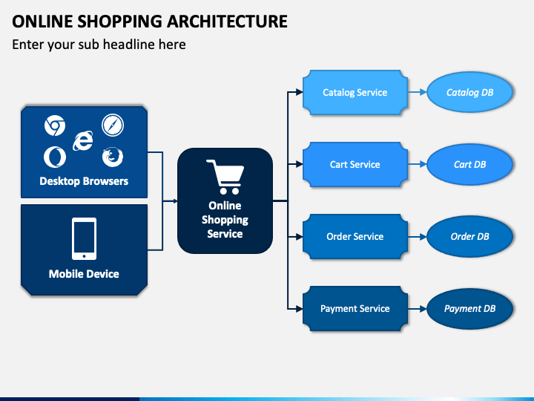

## Low Level Design

It refers to the detailed planning and structuring of how the system will be implemented to meet the specified requirements. It involves breaking down the system into smaller components, specifying their interactions, and defining how each component will function internally.

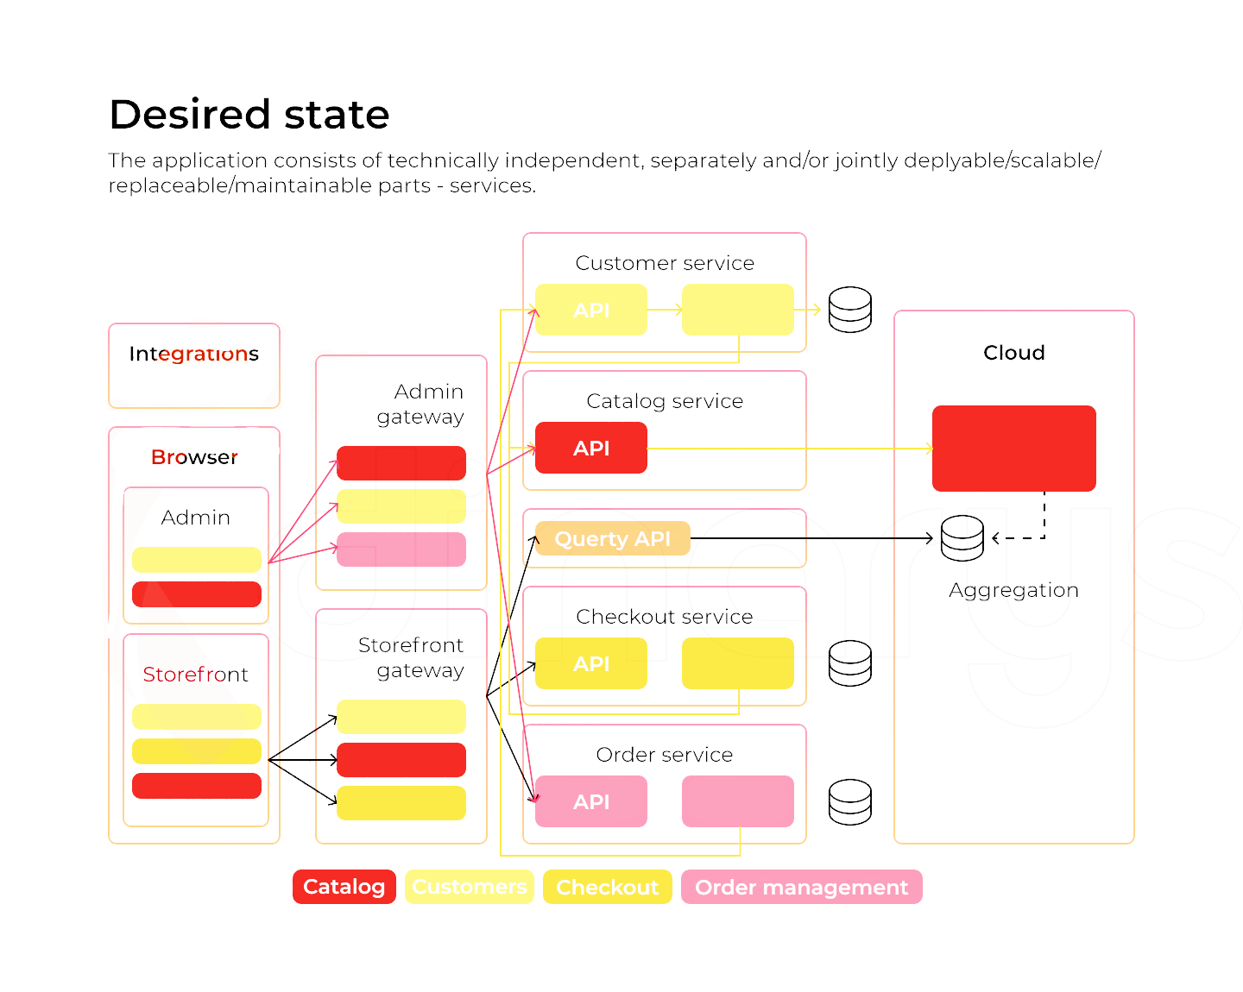

# Implementation

## Flow Chart

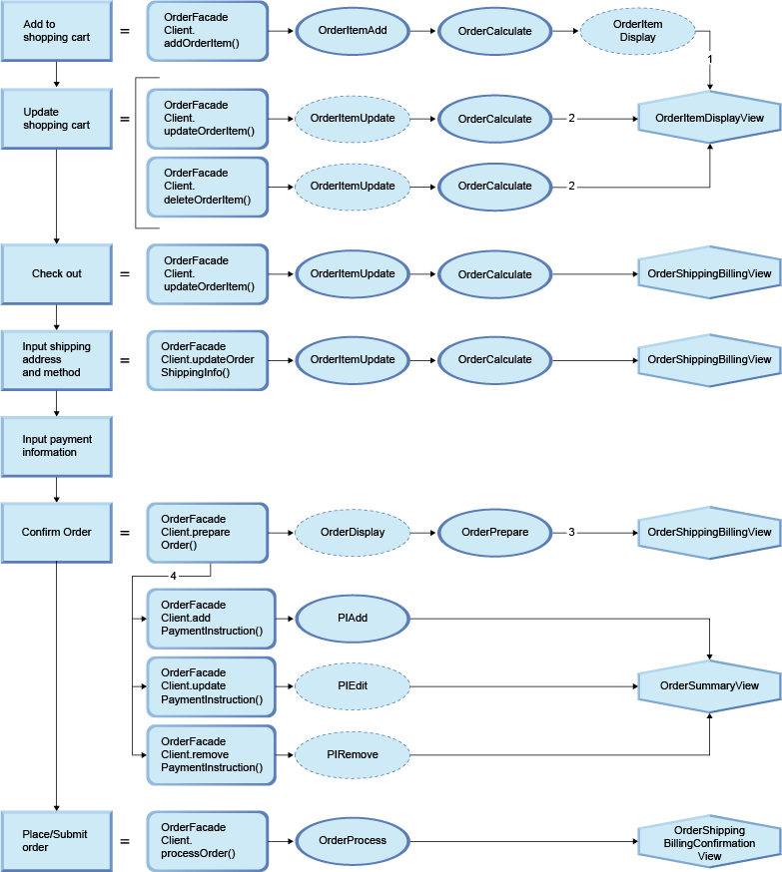

## Use Case Diagram

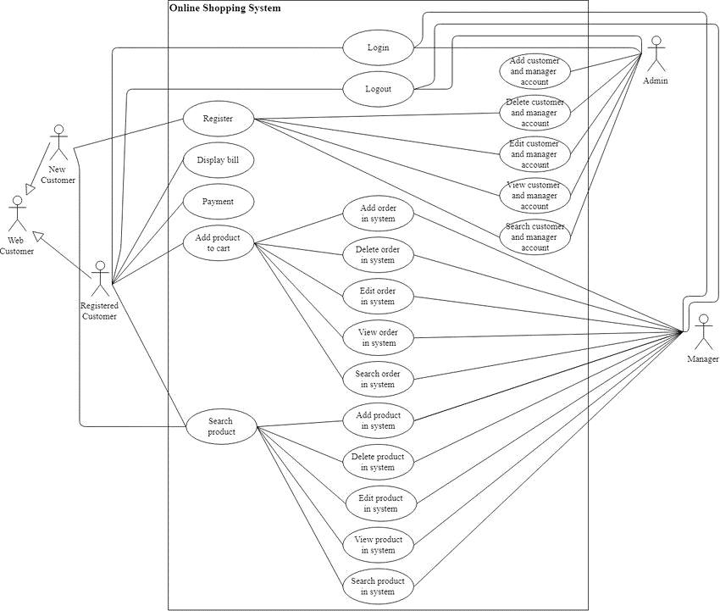

## Sequence Diagram

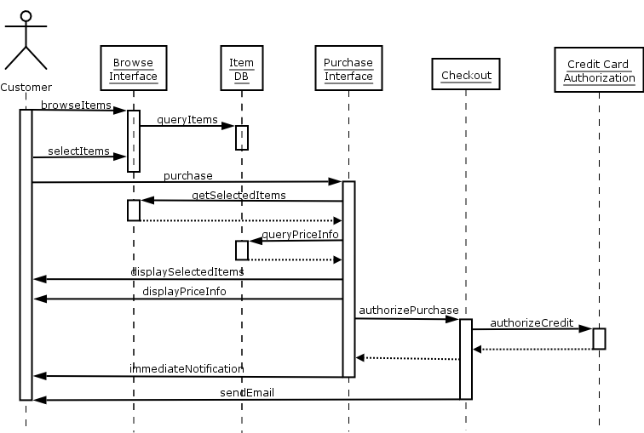

## Class Diagram

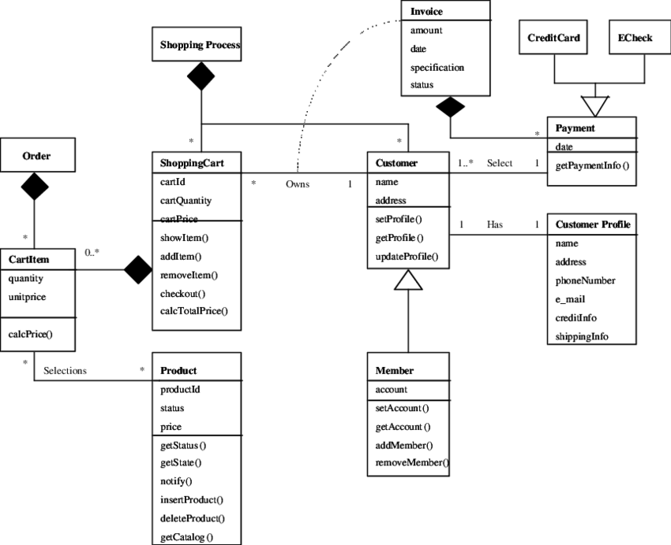

# Test Cases

* Test case 1: Verify that a new user can successfully register with valid details (name, email, password).
* Test case 2: Verify that registration fails if the user enters invalid or incomplete information.
* Test case 3: Verify that the system prevents duplicate registration with the same email address.
* Test case 4: Verify that users can search for products by entering keywords in the search bar.
* Test case 5: Verify that users can filter products by category, price range, brand, etc., and the results are accurate.
* Test case 6: Verify that the search and filter functionalities work correctly even with a large number of products.
* Test case 7: Verify that users can add products to their cart from the product details page.
* Test case 8: Verify that the cart updates dynamically when products are added or removed.
* Test case 9: Verify that users can update the quantity of products in the cart.
* Test case 10: Verify that users can proceed to checkout and enter shipping details.
* Test case 11: Verify that users can select a payment method and complete the checkout process successfully.
* Test case 12: Verify that the system calculates the order total correctly, including taxes and shipping charges.
* Test case 13: Verify that users can view their order history and track the status of their orders.
* Test case 14: Verify that admins can view all orders, update order status (processing, shipped, delivered), and generate invoices.
* Test case 15: Verify that users receive order confirmation emails with the correct order details.
* Test case 16: Verify that users can make payments using different payment methods (credit/debit cards, PayPal, etc.).
* Test case 17: Verify that the system handles payment failures gracefully and provides appropriate error messages.
* Test case 18: Verify that payment confirmation emails are sent to users after successful transactions.
* Test case 19: Verify that user passwords are stored securely (hashed and salted) in the database.
* Test case 20: Verify that sensitive information (e.g., payment details) is encrypted during transmission.
* Test case 21: Verify that the system has measures in place to prevent common security threats like SQL injection and XSS attacks.
* Test case 22: Verify that the user interface is intuitive and easy to navigate across different devices and screen sizes.
* Test case 23: Verify that error messages are clear and informative, guiding users to resolve issues effectively.
* Test case 24: Verify that the system performs well under varying loads, maintaining acceptable response times and usability.